Mission Peak Optics Inc.
Microspot Thin Film and White Light Measurement System MP100-ME-WL
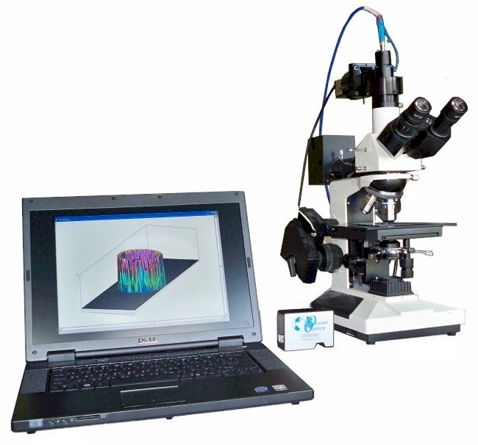
The MP100-ME-WL combines the thin film thickness measurement capability of our MP100-ME Thin Film Measurement system with Scanning White Light Interference (SWLI) capabilities. Utilizing a Piezo Objective Lens control the system is capable of positioning the z-direction of the Mirau objective lens. And combined with image processing through a CCD camera enables a non-contact as well as non-destructive Surface Profiling method superior to the Alpha Step method for identifying the difference in thickness.

The CCD camera connects directly via USB from our microspot attachment to the included computer. It is High Resolution and full color to accurately capture the SWLI images. The USB 2.0 technology quickly transfers this captured image from the camera to the computer. And the Piezo control moves the objective lens in small increments to capture all the Fringes created by the reflected images of the surface.

The MP100-ME-WL starts out at a low price. The following integral components and their accessories are included in the starting price: High-end Notebook computer with Core 2 Duo processor running Windows XP Operating System. Compact High-speed USB 2.0 spectrometer. Piezo Objective Lens control. 972RT Microscope with both Reflection and Transmission modules for measuring transparent samples. Microspot adapter that connects Microscope to the USB spectrometer via fiber optic cable (see Architecture drawing) as well as transmits the microscope display image to the CCD camera. CCD USB camera for capturing the microscope display image to the computer.

MP100-ME-WL Microspot Thin Film and White Light Measurement System

Fiber Optics

Spectrometer

Slit

Aperture
High Resolution Color Camera to capture Fringes

Light Source
Imaging Processor
Piezo Controller



Mirau Interference
Objective

PC to interface all components together

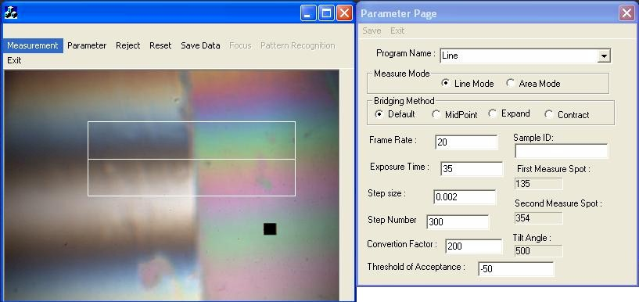
The MP100-ME-WL measurement software interface also operates in conjunction with Microsoft Office™, which allows the operator to save measurement data directly in MS EXCEL™ spreadsheet format and store it within an MS ACCESS™ database quickly and easily for reference. The White Light software displays a real-time image of the surfaces as they are being scanned along with other graphical display windows that summarize those measurement values. Square on the view screen represents the measurement area. Can be resized or moved. Horizontal line represents the white light interference’s phase difference in the graph between the two surfaces. After scanning, a 3D map of the surface can be generated using these values.
Real-time image captured during SWLI (Scanning White Light Interference) Method.

Once an image of the white light interference is located using the manual focus and X-Y Stage movement the display screen should show a similar image as above. The box shaped grid on this real-time image denotes where the software simultaneously captures and scans both sides of the white light interference.

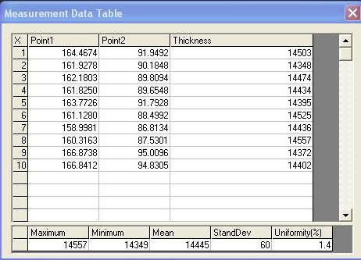
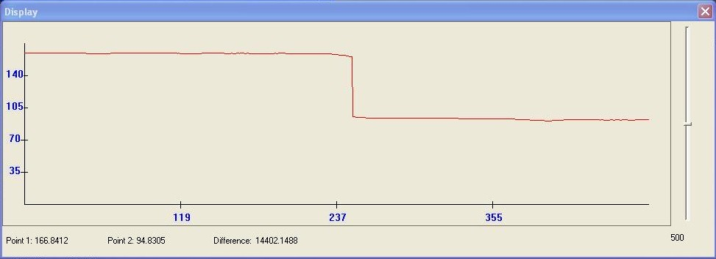

SWLI 2D Mode specifications:
Microscope stage comes with tilt adjustment capability to align the microscope objective and measurement surface in a perfect 90° angle, so the step difference will have zero angle correction. The system is also designed to operate within a normal environment without the need for an expensive vibration isolation table.

The SWLI speed is 10 seconds per scanning measurement.
Maximum Measurement range is < 50 micron.
Resolution of the system is 0.03 micron.
Accuracy will be 3%.

System also comes with a calibration standard for the Thickness Measurement utilizing Fresnel’s Interference Technique. This standard is designed to calibrate both of the measurement methods: SWLI mode and Fresnel’s thickness measurement mode.

The MP100-ME-WL is a complete thickness measurement tool for transparent and opaque film. One system provides a total solution for a multitude of film types. This one system eliminates the necessity to have multiple devices to find out the actual thickness for diverse materials.
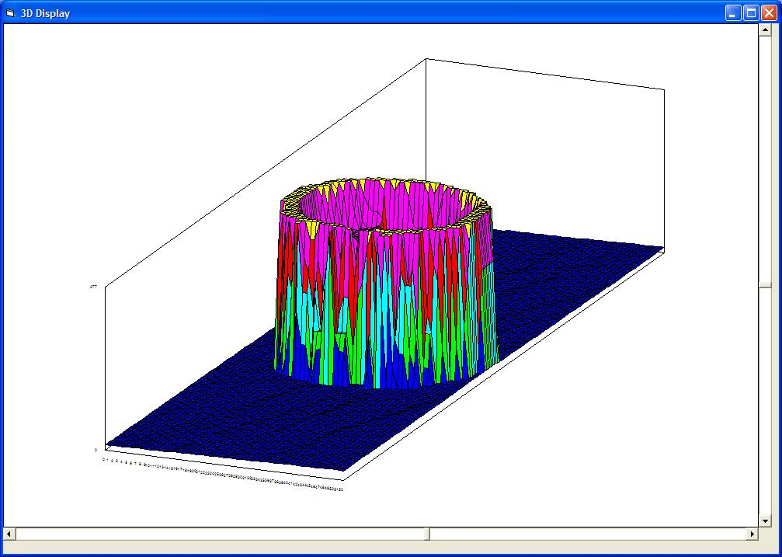

SWLI 3D mode specifications:
Create a 3D display of an area 50 microns by 150 microns within 30 seconds post-measurement.
The measurement area can be preset by customer choice
An artifact rejection algorithm used for the “Low Reflectivity Edge”, which can cause uncertainty on the Z-position definition.

Reducing the cost:
The MP100-ME-WL system is designed for a low cost approach without requiring additional expenses such as adding on costly accessories like a Vibration Isolation Table. It shares one optical setup for all the components: Light Source, Microscope, Computer, Controller, Spectrometer, and CCD camera. Those are common components for both thickness measurement methods and are all included in our system’s cost quotation. Also at no additional charge, Mission Peak Optics responsibly ensures that our systems will perform at the customer’s application via personal on-site training and continued technical support.
3D Mapped image
Mission Peak Optics Inc.
Microspot Thin Film and White Light Measurement System MP100-ME-WL
Easy to use + Low Cost + Compact Size + Flexibility = High Performance
All the features of the MP100-ME system in regards to non-contact thin film thickness measurement are 100% intact without any concessions in performance.

The System comes standard with a manual metalllurgical microscope, which is designed to fit your application needs. MP100-ME-WL provides state-of-the-art functions to measure filled cell gap on LCD, polyemide on ITO, color filter CIE chromaticity, and color filter thickness. MP100-ME is also able to measure Oxide, Nitride, Photoresist and Polysilicon films. The powerful software algorithms can perform single, double, and triple layer thickness calculations. As well as special search and fit routines that quickly converge the algorithm and variables in an accurate thickness measurement tool.

The MP100-ME-WL USB spectrometer uses multiple gratings to achieve a wide spectrum range from UV to NIR. The spectrometer bridges the microscope to the notebook computer through a USB cable and Single Fiber Optic Cable. Detaching the Fiber Optic Cable from the microscope attachment can make the system compact and portable if necessary. The unique video display design of the microscope attachment provides the operator with an ergonomic view of the sample area thus eliminating tedious viewing through conventional microscope optics.

The MP100-ME-WL user interface is divided into four quadrants that represent measurement, setup parameters, visual spectral display, thickness result bar graph and a thickness result data table. This fully illustrated interface provides instant data return. The main MPO software also operates in conjunction with Microsoft Office™, which allows the operator to save measurement data in MS EXCEL™ format and store it within an MS ACCESS™ database for future reference. This collaboration of software allows you to generate the measurement reports that you need fast and easily.
MP100-ME-WL Microspot Thin Film and White Light Measurement System

Computer
Spectrometer
Fiber Optics

Slit

Microscope
Aperture
CCD USB
camera

Light Source

Objective Lens

Sample

MP100-ME-WL Architecture
Light Source

Specifications (MP100-ME-WL):

Scanning range: 380 nm to 950 nm standard
Spectrum resolution: 2 nm
Precision: 0.2 nm
Measuring speed: 2 seconds

Measurement specification:

 |  | 1st Layer |  | 2nd Layer |  | 3rd Layer  0 -10,000Å |  | 4th Layer  0 -10,000Å
Film Type | Objective  Lens | Range | 1σ | Range | 1σ | Range | 1σ | Range | 1σ
P1/P2/ITO/Oxide/Gla | 5x, 10x | 100 - 30,000Å | 5Å | 100 - 10,000Å | 5Å | 100 - 2,000Å | 3Å | 100 - 3,000Å | 3Å
Oxide/Si | 5x, 10x | 200 - 30,000Å | 2Å
 |  | 30,000,- 50,000Å | 5Å
 | 40x,60x | 200 - 10,000Å | 2Å
 |  | 10,000 - 20,000Å | 5Å
Nitride/Si | 5x, 10x | 150 - 20,000Å | 2Å
 | 40x, 60x | 150 - 15,000Å | 2Å
Photoresist/Si | 5x, 10x, 40x | 500 - 20,000Å | 5Å
Nitride/Oxide/Si | 5x, 10x | 150 - 20,000Å | 5Å | 100 - 10,000Å | 5Å
Poly/Oxide/Si | 5x, 10x | 100 - 5,000Å | 5Å | 100 - 10,000Å | 5Å
Oxide/Poly/Oxide/Si | 5x, 10x | 100 - 10,000Å | 5Å | 0 - 10,000Å | 5Å | 0 - 10,000Å | 5Å
Oxide/Al | 5x, 10x, 40x | 2,000 - 20,000Å | 5Å
Photoresist/Cr | 5x, 10x, 40x | 500 - 20,000Å | 5Å
Oxide/NiFe | 5x, 10x, 40x | 2,000 - 20,000Å | 5Å
Photoresist/Glass | 5x, 10x, 40x | 500 - 20,000Å | 10Å
ITO/Oxide/Glass | 5x, 10x, 40x | 100 - 3,000Å | 2Å | 100 - 2,000Å | 2Å
CIE Color measurement | 5x
Very Thick Film | 5x | 50,000-150,000Å | 100Å
Customized film types are available for your applications.

Measuring spot size: 5x Objective is 50 microns
Viewing options: 2" camcorder screen, and dual microscope eyepiece lenses. Also applies to Transmission mode.

Mission Peak Optics Inc.
46941 Rancho Higuera Road, Fremont, CA 94539 USA
Tel: (510) 438-0384 Fax: (510) 438-9795
Website: www.missionpeakoptics.com Email: sales@missionpeakoptics.com

